Saint Martin Lutheran Church
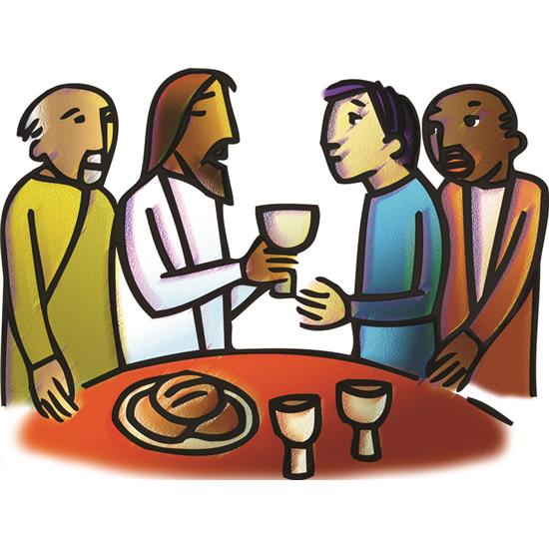

Maundy Thursday
April 2, 2026, 7:00 pm

Welcome to the worship of our Lord and Savior Jesus Christ!

This evening our Lenten observance comes to an end, and we gather with Christians around the world to celebrate the Three Days of Jesus’ death and resurrection. Tonight we remember Christ’s last meal with his disciples, but the central focus is his commandment that we live out the promise embodied in this meal. As Jesus washed his disciples’ feet, so we are called to give and receive love in humble service to one another. Formed into a new body in Christ through this holy meal, we are transformed by the mercy we have received and carry it into the world. Departing worship in solemn silence, we anticipate the coming days.

PRELUDE
Please silence electronic devices during this quiet time of preparing our hearts for worship.

Stand
WELCOME AND INTRODUCTION TO MAUNDY THURSDAY
P Blessed be the Lord, who forgives all our sins and whose mercy endures forever.
P The Lord be with you.
C And also with you.

P Tonight, we begin the Great Three Days of our Lord’s passion, death, and resurrection, the journey from the supper table to the cross, and from the cross to Easter Dawn. We are followers in his way, exploring his truth, encountering his life. This is the night when Christ the Lamb of God gave himself into the hands of those who would betray him. This is the night when Christ gathered with his disciples in the Upper Room.

C This is the night when Christ our Lord gave us this holy feast, that as we break the bread and drink the cup we may proclaim his holy sacrifice, and come at the last to his table in heaven.

P This is the night when Christ took a towel and washed his disciples’ feet, showing us how to honor and serve one another in love.

C This is the night for watching and prayer.

P We give ourselves freely to the call of these great days, confident that those who die in Christ will surely live in him.

Silence for reflection and self-examination.

CONFESSION AND FORGIVENESS

P Friends in Christ, in this Lenten season we have heard our Lord’s call to struggle against sin, death, and the devil — all that keeps us from loving God and each other. This is the struggle to which we were called at baptism. Within the community of the church, God never wearies of forgiving sin and giving the peace of reconciliation. On this night let us confess our sin against God and our neighbor, and enter the celebration of the great Three Days reconciled with God and with one another.

P Most merciful God,

C we confess that we are in bondage to sin and cannot free ourselves. We have sinned against you in thought, word, and deed, by what we have done and by what we have left undone. We have not loved you with our whole heart; we have not loved our neighbors as ourselves. For the sake of your Son, Jesus Christ, have mercy on us. Forgive us, renew us, and lead us, so that we may delight in your will and walk in your ways, to the glory of your holy name. Amen.

P In the mercy of almighty God, Jesus Christ was given to die for us, and for his sake God forgives us all our sins. As a called and ordained minister of the church of Christ, and by his authority, I therefore declare to you the entire forgiveness of all your sins, in the name of the Father, and of the + Son, and of the Holy Spirit.
C Amen.

PRAYER OF THE DAY

P The Lord be with you.
C And also with you.

P Holy God, source of all love, on the night of his betrayal, Jesus gave us a new commandment, to love one another as he loves us. Write this commandment in our hearts and give us the will to serve others as he was the servant of all, your Son, Jesus Christ, our Savior and Lord, who lives and reigns with you and the Holy Spirit, one God, now and forever.
C Amen.
Sit

THE FIRST PASSOVER Exodus 12:1-14
A reading from Exodus:

¹The LORD said to Moses and Aaron in the land of Egypt, ²“This month shall be for you the beginning of months. It shall be the first month of the year for you. ³Tell all the congregation of Israel that on the tenth day of this month every man shall take a lamb according to their fathers' houses, a lamb for a household. ⁴And if the household is too small for a lamb, then he and his nearest neighbor shall take according to the number of persons; according to what each can eat you shall make your count for the lamb. ⁵Your lamb shall be without blemish, a male a year old. You may take it from the sheep or from the goats, ⁶and you shall keep it until the fourteenth day of this month, when the whole assembly of the congregation of Israel shall kill their lambs at twilight.

⁷“Then they shall take some of the blood and put it on the two doorposts and the lintel of the houses in which they eat it. ⁸They shall eat the flesh that night, roasted on the fire; with unleavened bread and bitter herbs they shall eat it. ⁹Do not eat any of it raw or boiled in water, but roasted, its head with its legs and its inner parts. ¹⁰And you shall let none of it remain until the morning; anything that remains until the morning you shall burn. ¹¹In this manner you shall eat it: with your belt fastened, your sandals on your feet, and your staff in your hand. And you shall eat it in haste. It is the Lord's Passover. ¹²For I will pass through the land of Egypt that night, and I will strike all the firstborn in the land of Egypt, both man and beast; and on all the gods of Egypt I will execute judgments: I am the LORD. ¹³The blood shall be a sign for you, on the houses where you are. And when I see the blood, I will pass over you, and no plague will befall you to destroy you, when I strike the land of Egypt.
¹⁴“This day shall be for you a memorial day, and you shall keep it as a feast to the LORD; throughout your generations, as a statute forever, you shall keep it as a feast.
OFFERING
The ushers collect our gifts of tithes and offerings, the ministers make ready the bread and wine.

Special Music Andrew and Leslie Kollmeyer

JESUS WASHES THE DISCIPLES’ FEET John 13:1-17
A reading from the Gospel of John:

¹Now before the Feast of the Passover, when Jesus knew that his hour had come to depart out of this world to the Father, having loved his own who were in the world, he loved them to the end. ²During supper, when the devil had already put it into the heart of Judas Iscariot, Simon's son, to betray him, ³Jesus, knowing that the Father had given all things into his hands, and that he had come from God and was going back to God, ⁴rose from supper. He laid aside his outer garments, and taking a towel, tied it around his waist. ⁵Then he poured water into a basin and began to wash the disciples' feet and to wipe them with the towel that was wrapped around him. ⁶He came to Simon Peter, who said to him, “Lord, do you wash my feet?” ⁷Jesus answered him, “What I am doing you do not understand now, but afterward you will understand.” ⁸Peter said to him, “You shall never wash my feet.” Jesus answered him, “If I do not wash you, you have no share with me.” ⁹Simon Peter said to him, “Lord, not my feet only but also my hands and my head!” ¹⁰Jesus said to him, “The one who has bathed does not need to wash, except for his feet, but is completely clean. And you are clean, but not every one of you.” ¹¹For he knew who was to betray him; that was why he said, “Not all of you are clean.”¹²When he had washed their feet and put on his outer garments and resumed his place, he said to them, “Do you understand what I have done to you? ¹³You call me Teacher and Lord, and you are right, for so I am. ¹⁴If I then, your Lord and Teacher, have washed your feet, you also ought to wash one another's feet. ¹⁵For I have given you an example, that you also should do just as I have done to you. ¹⁶Truly, truly, I say to you, a servant is not greater than his master, nor is a messenger greater than the one who sent him. ¹⁷If you know these things, blessed are you if you do them..

INVITATION TO FOOT WASHING

P On this night we have heard our Lord’s commandment to love one another as he has loved us. We who receive God’s love in Jesus Christ are called to love one another, to be servants to each other as Jesus became our servant. Our commitment to this loving service is signified in the washing of feet, following the example our Lord gave us on the night before his death.
The presiding minister may wash the feet of all who desire to participate.

HYMN ELW #360
LOVE CONSECRATES THE HUMBLEST ACT
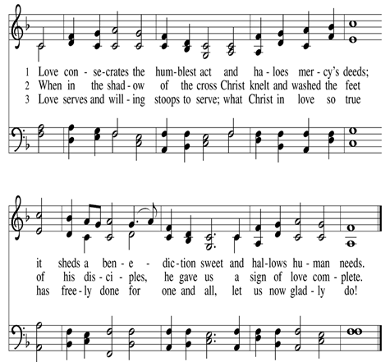

THE INSTITUTION OF THE LORD’S SUPPER Matthew 26:26-29
A reading from the Gospel of Matthew

²⁶Now as they were eating, Jesus took bread, and after blessing it broke it and gave it to the disciples, and said, “Take, eat; this is my body.” ²⁷And he took a cup, and when he had given thanks he gave it to them, saying, “Drink of it, all of you, ²⁸for this is my blood of the covenant, which is poured out for many for the forgiveness of sins. ²⁹I tell you I will not drink again of this fruit of the vine until that day when I drink it new with you in my Father's kingdom.”

HOLY COMMUNION

Stand
WORDS OF INSTITUTION
P In the night in which he was betrayed,
our Lord Jesus took bread, and gave thanks;
broke it, and gave it to his disciples, saying:
Take and eat; this is my body, given for you.
Do this for the remembrance of me.

Again, after supper, he took the cup, gave thanks,
and gave it for all to drink, saying:
This cup is the new covenant in my blood,
shed for you and for all people for the forgiveness of sin.
Do this for the remembrance of me.

LORD’S PRAYER
C Our Father, who art in heaven, hallowed be thy name, thy kingdom come, thy will be done, on earth as it is in heaven. Give us this day our daily bread; and forgive us our trespasses, as we forgive those who trespass against us; and lead us not into temptation, but deliver us from evil. For thine is the kingdom, and the power, and the glory, forever and ever. Amen.

Sit

INVITATION TO HOLY COMMUNION

COMMUNION HYMNS
PANIS ANGELICUS Arr C. Franck
Rita Mathsen, Leslie Kollmeyer and Andrew Kollmeyer

Lord, Who the Night You Were Betrayed ELW #463

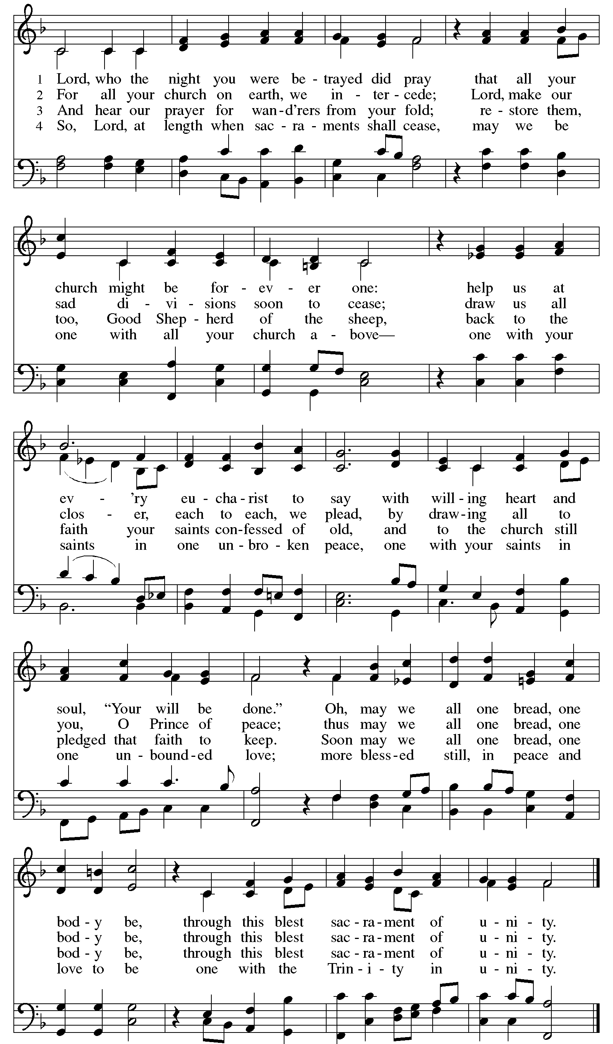
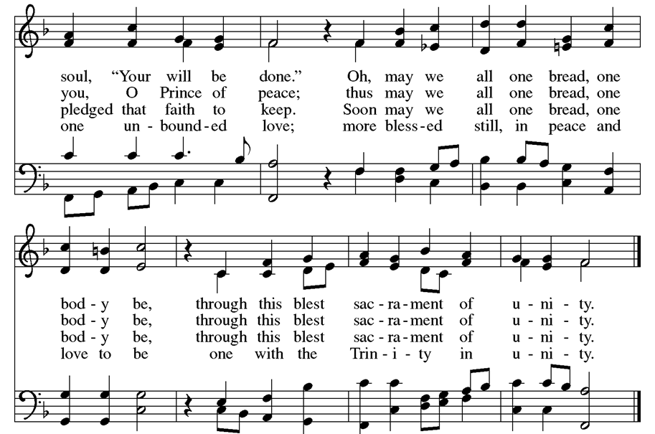

Psalm 116:1-2, 12-19

C ¹I love the LORD, because he has heard
my voice and my supplications.
²Because he inclined his ear to me,
therefore I will call on him as long as I live.
¹²What shall I return to the LORD
for all his bounty to me?
¹³I will lift up the cup of salvation
and call on the name of the LORD,
¹⁴I will pay my vows to the LORD
in the presence of all his people.
¹⁵Precious in the sight of the LORD
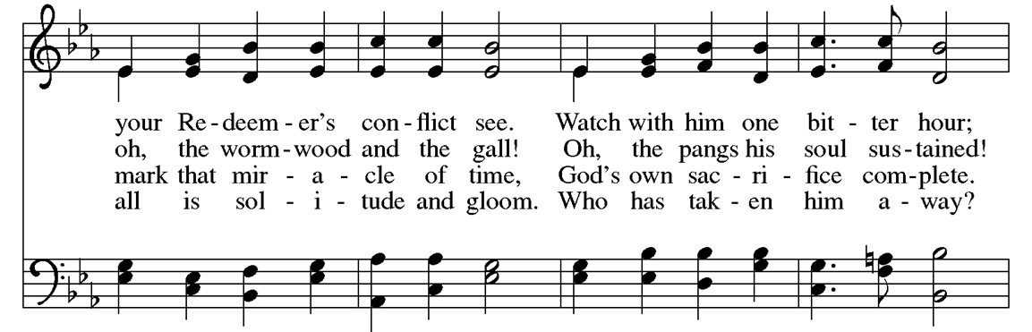
is the death of his faithful ones.
¹⁶O LORD, I am your servant;
I am your servant, the child of your serving girl.
You have loosed my bonds.
¹⁷I will offer to you a thanksgiving sacrifice
and call on the name of the LORD.
¹⁸I will pay my vows to the LORD
in the presence of all his people,
¹⁹in the courts of the house of the LORD,
in your midst, O Jerusalem.
Praise the LORD!

JESUS FORETELLS PETER’S DENIAL John 13:34-38
A reading from the Gospel of John.

³⁴A new commandment I give to you, that you love one another: just as I have loved you, you also are to love one another. ³⁵By this all people will know that you are my disciples, if you have love for one another.” ³⁶Simon Peter said to him, “Lord, where are you going?” Jesus answered him, “Where I am going you cannot follow me now, but you will follow afterward.” ³⁷Peter said to him, “Lord, why can I not follow you now? I will lay down my life for you.” ³⁸Jesus answered, “Will you lay down your life for me? Truly, truly, I say to you, the rooster will not crow till you have denied me three times.

Stand
HYMN Ah, Holy Jesus ELW #349, Verses 1 and 2

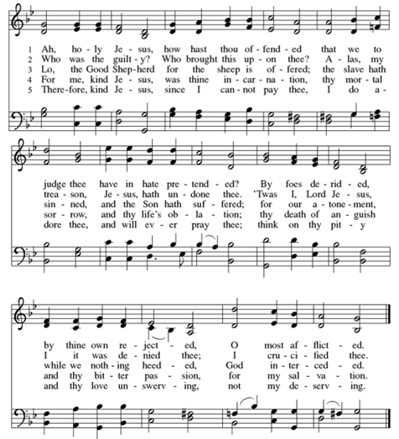

Sit

THE BETRAYAL AND ARREST OF JESUS John 18:1-12
A reading from the Gospel of John:

When Jesus had spoken these words, he went out with his disciples across the brook Kidron, where there was a garden, which he and his disciples entered. ²Now Judas, who betrayed him, also knew the place, for Jesus often met there with his disciples. ³So Judas, having procured a band of soldiers and some officers from the chief priests and the Pharisees, went there with lanterns and torches and weapons. ⁴Then Jesus, knowing all that would happen to him, came forward and said to them, “Whom do you seek?” ⁵They answered him, “Jesus of Nazareth.” Jesus said to them, “I am he.” Judas, who betrayed him, was standing with them. ⁶When Jesus said to them, “I am he,” they drew back and fell to the ground. ⁷So he asked them again, “Whom do you seek?” And they said, “Jesus of Nazareth.” ⁸Jesus answered, “I told you that I am he. So, if you seek me, let these men go.” ⁹This was to fulfill the word that he had spoken: “Of those whom you gave me I have lost not one.” ¹⁰Then Simon Peter, having a sword, drew it and struck the high priest's servant and cut off his right ear. (The servant's name was Malchus.) ¹¹So Jesus said to Peter, “Put your sword into its sheath; shall I not drink the cup that the Father has given me?” ¹²So the band of soldiers and their captain and the officers of the Jews arrested Jesus and bound him.

Stand

HYMN Go To Dark Gethsemane ELW #347, Verses 1 and 2
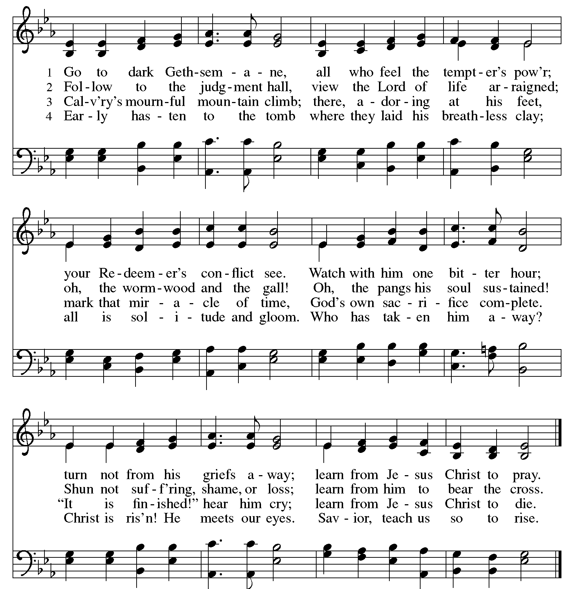
Sit

JESUS FORTELLS PETER’S DENIAL John 18:15-27
¹⁵Simon Peter followed Jesus, and so did another disciple. Since that disciple was known to the high priest, he entered with Jesus into the courtyard of the high priest, ¹⁶but Peter stood outside at the door. So the other disciple, who was known to the high priest, went out and spoke to the servant girl who kept watch at the door, and brought Peter in. ¹⁷The servant girl at the door said to Peter, “You also are not one of this man's disciples, are you?” He said, “I am not.” ¹⁸Now the servants and officers had made a charcoal fire, because it was cold, and they were standing and warming themselves. Peter also was with them, standing and warming himself.

¹⁹The high priest then questioned Jesus about his disciples and his teaching. ²⁰Jesus answered him, “I have spoken openly to the world. I have always taught in synagogues and in the temple, where all Jews come together. I have said nothing in secret. ²¹Why do you ask me? Ask those who have heard me what I said to them; they know what I said.” ²²When he had said these things, one of the officers standing by struck Jesus with his hand, saying, “Is that how you answer the high priest?” ²³Jesus answered him, “If what I said is wrong, bear witness about the wrong; but if what I said is right, why do you strike me?” ²⁴Annas then sent him bound to Caiaphas the high priest. ²⁵Now Simon Peter was standing and warming himself. So they said to him, “You also are not one of his disciples, are you?” He denied it and said, “I am not.” ²⁶One of the servants of the high priest, a relative of the man whose ear Peter had cut off, asked, “Did I not see you in the garden with him?” ²⁷Peter again denied it, and at once a rooster crowed.

Musical Meditation Andrew Kollmeyer

COMPLETION OF STRIPPING THE ALTAR AND SANCTUARY
In preparation for Good Friday, the altar and sanctuary are left barren. You are invited to sit and contemplate Christ’s great love and sacrifice for us, leaving when you choose. The Lord bless and keep you this night and always.

From sundaysandseasons.com. Copyright © 2024 Augsburg Fortress. All rights reserved. Reprinted by permission under Augsburg Fortress Liturgies Annual License # SB155749.

